Gyrobicupola

Definition
# Source: AI Source: Provided by: [Data Path: Persons Table -> ID Column: 1, Name_En Column: Motasem Essam] -> From: [ChatGPT] on [7/25/2026]
A Gyrobicupola is a polyhedron formed by joining two identical cupolas at their larger polygonal bases, with one cupola rotated relative to the other.
The rotation causes the triangular faces of one cupola to meet the square faces of the other cupola around the joining region. This distinguishes it from an Orthobicupola, where corresponding face arrangements are aligned.
A gyrobicupola has:
- Two opposite $n$-gonal faces.
- $2n$ triangular faces.
- $2n$ square faces.
- Two cupolas joined at their larger $2n$-gonal bases.

Geometric Structure
# Source: AI Source: Provided by: [Data Path: Persons Table -> ID Column: 1, Name_En Column: Motasem Essam] -> From: [ChatGPT] on [7/25/2026]
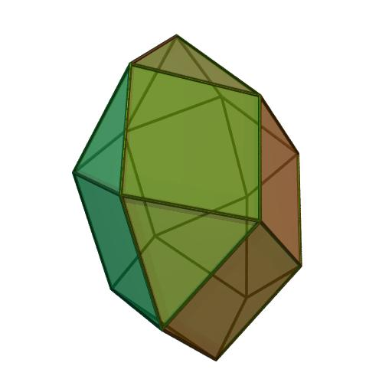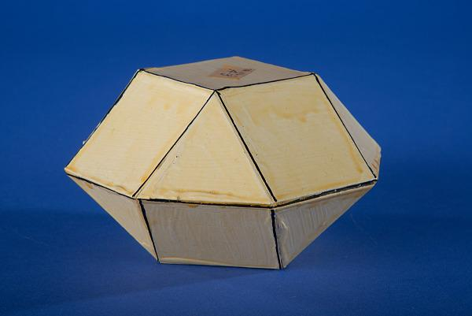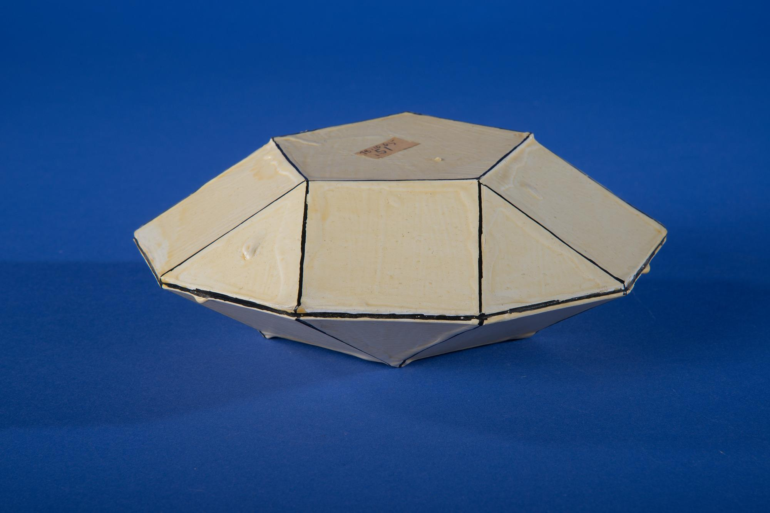
Its main elements are:
- Upper Polygonal Face: The smaller polygon at the top.
- Lower Polygonal Face: The smaller polygon at the bottom.
- Upper Cupola: The upper component of the solid.
- Lower Cupola: The lower component of the solid.
- Triangular Faces: $2n$ external triangular faces.
- Square Faces: $2n$ external square faces.
- Central Joining Region: The shared $2n$-gonal base connecting the two cupolas.
- Vertices: The points where edges meet.
- Edges: The line segments forming the boundaries of the faces.
- Height: The perpendicular distance between the two opposite polygonal faces.

Face Composition
# Source: AI Source: Provided by: [Data Path: Persons Table -> ID Column: 1, Name_En Column: Motasem Essam] -> From: [ChatGPT] on [7/25/2026]
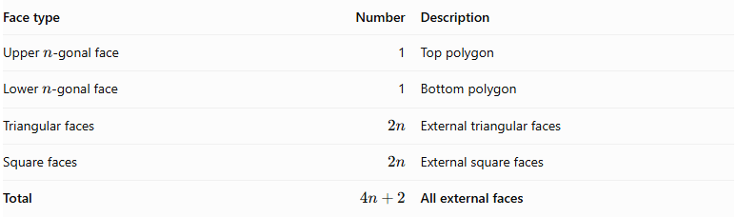
Face type | Number | Description
Upper $n$-gonal face | 1 | Top polygon
Lower $n$-gonal face | 1 | Bottom polygon
Triangular faces | $$2n$$ | External triangular faces
Square faces | $$2n$$ | External square faces
Total | $$4n+2$$ | All external faces
The two larger $2n$-gonal bases are joined internally and are not counted as external faces.

Mathematical Properties
# Source: AI Source: Provided by: [Data Path: Persons Table -> ID Column: 1, Name_En Column: Motasem Essam] -> From: [ChatGPT] on [7/25/2026]
For a generalized $n$-gonal gyrobicupola:
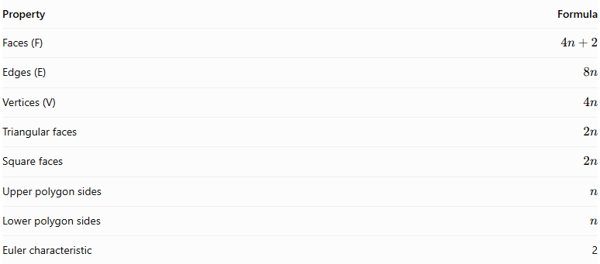
Property | Formula
Faces (F) | $$4n+2$$
Edges (E) | $$8n$$
Vertices (V) | $$4n$$
Triangular faces | $$2n$$
Square faces | $$2n$$
Upper polygon sides | $$n$$
Lower polygon sides | $$n$$
Euler characteristic | 2
Euler's Formula:
$$V-E+F=2$$
$$4n-8n+(4n+2)=2$$

Examples
# Source: AI Source: Provided by: [Data Path: Persons Table -> ID Column: 1, Name_En Column: Motasem Essam] -> From: [ChatGPT] on [7/25/2026]
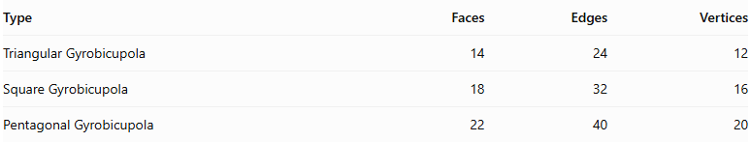
Type | Faces | Edges | Vertices
Triangular Gyrobicupola | 14 | 24 | 12
Square Gyrobicupola | 18 | 32 | 16
Pentagonal Gyrobicupola | 22 | 40 | 20

Types of Gyrobicupolas

Triangular Gyrobicupola
# Source: AI Source: Provided by: [Data Path: Persons Table -> ID Column: 1, Name_En Column: Motasem Essam] -> From: [ChatGPT] on [7/25/2026]
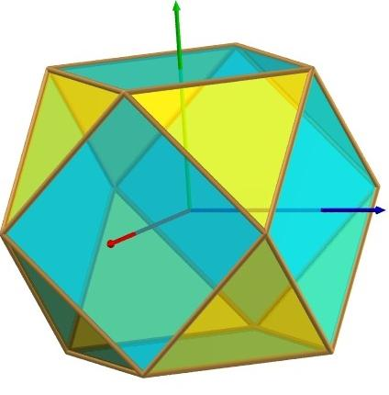
A Triangular Gyrobicupola is formed by joining two triangular cupolas along their hexagonal bases, with one cupola rotated ${60}^{∘}$ relative to the other.
- 8 equilateral triangular faces.
- 6 square faces.
- 14 faces, 24 edges, and 12 vertices.
- It is geometrically identical to the Cuboctahedron, an Archimedean solid.

Square Gyrobicupola
# Source: AI Source: Provided by: [Data Path: Persons Table -> ID Column: 1, Name_En Column: Motasem Essam] -> From: [ChatGPT] on [7/25/2026]
A Square Gyrobicupola is formed by joining two square cupolas along their octagonal bases, with one cupola rotated ${45}^{∘}$ relative to the other.
- 8 equilateral triangular faces.
- 10 square faces.
- 18 faces, 32 edges, and 16 vertices.
- It is Johnson solid $J_{29}$.

Pentagonal Gyrobicupola
# Source: AI Source: Provided by: [Data Path: Persons Table -> ID Column: 1, Name_En Column: Motasem Essam] -> From: [ChatGPT] on [7/25/2026]
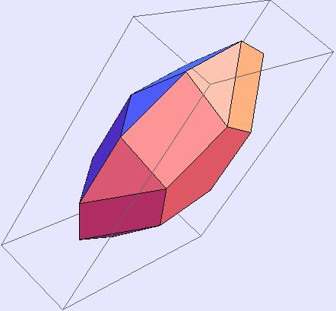
A Pentagonal Gyrobicupola is formed by joining two pentagonal cupolas along their decagonal bases, with one cupola rotated ${36}^{∘}$ relative to the other.
- 10 equilateral triangular faces.
- 10 square faces.
- 2 pentagonal faces.
- 22 faces, 40 edges, and 20 vertices.
- It is Johnson solid $J_{31}$.

Note: These are the three standard regular-faced convex examples in the Johnson-solid family. The generalized $n$-gonal construction describes the broader geometric arrangement; not every value of $n$ necessarily produces a convex solid with all regular faces.

Geometric Characteristics
# Source: AI Source: Provided by: [Data Path: Persons Table -> ID Column: 1, Name_En Column: Motasem Essam] -> From: [ChatGPT] on [7/25/2026]
- It is formed by joining two identical cupolas at their larger polygonal bases.
- One cupola is rotated relative to the other.
- Triangular faces of one cupola meet square faces of the other around the joining region.
- It has two opposite $n$-gonal faces.
- It contains $2n$ triangular faces.
- It contains $2n$ square faces.
- It has $4n+2$ external faces.
- It has $8n$ edges.
- It has $4n$ vertices.
- Its central joining polygon is internal and is not counted as an external face.

Construction of Gyrobicupola

Geometric Instruments Used
# Source: AI Source: Provided by: [Data Path: Persons Table -> ID Column: 1, Name_En Column: Motasem Essam] -> From: [ChatGPT] on [7/25/2026]
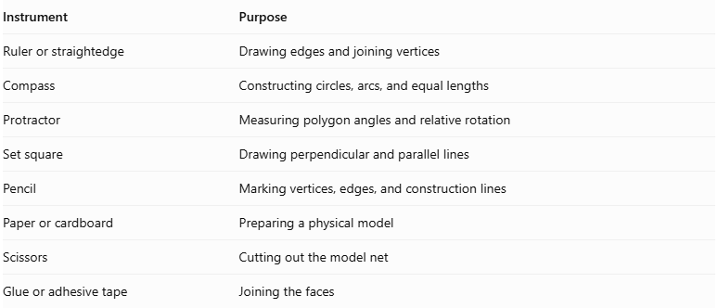
Instrument | Purpose
Ruler or straightedge | Drawing edges and joining vertices
Compass | Constructing circles, arcs, and equal lengths
Protractor | Measuring polygon angles and relative rotation
Set square | Drawing perpendicular and parallel lines
Pencil | Marking vertices, edges, and construction lines
Paper or cardboard | Preparing a physical model
Scissors | Cutting out the model net
Glue or adhesive tape | Joining the faces

Instrument-Based Construction Procedures

Construct the First Cupola
# Source: AI Source: Provided by: [Data Path: Persons Table -> ID Column: 1, Name_En Column: Motasem Essam] -> From: [ChatGPT] on [7/25/2026]
- Select the polygon order $n$.
- Draw a regular $2n$-sided polygon to serve as the larger base.
- Construct the smaller regular $n$-sided top.
- Arrange the smaller polygon above the larger polygon according to the cupola structure.
- Construct the $n$ triangular and $n$ square lateral faces.
- Check that all adjacent faces share matching edges.

Construct the Second Cupola
# Source: AI Source: Provided by: [Data Path: Persons Table -> ID Column: 1, Name_En Column: Motasem Essam] -> From: [ChatGPT] on [7/25/2026]
- Draw another cupola with the same dimensions.
- Ensure that its larger base is congruent to the first cupola's larger base.
- Ensure that its smaller polygon and lateral faces match the corresponding dimensions of the first cupola.
- Keep the second cupola separate until the rotational arrangement is established.

Rotate the Second Cupola
# Source: AI Source: Provided by: [Data Path: Persons Table -> ID Column: 1, Name_En Column: Motasem Essam] -> From: [ChatGPT] on [7/25/2026]
- Identify the center of the shared regular $2n$-gon.
- Mark the required rotation angle:
$$α=\frac{{180}^{°}}{n}$$
- Rotate the second cupola around the central axis by this angle.
- Check that its joining polygon remains congruent and aligned with the first cupola's joining polygon.

Join the Two Cupolas
# Source: AI Source: Provided by: [Data Path: Persons Table -> ID Column: 1, Name_En Column: Motasem Essam] -> From: [ChatGPT] on [7/25/2026]
- Place the two larger polygonal bases opposite one another.
- Match the vertices and edges of the shared $2n$-gon.
- Join the two cupolas in the rotated gyro arrangement.
- Ensure that the triangular faces of one cupola meet the square faces of the other along the joining region.
- Treat the shared polygonal bases as internal faces.
- Check that the exterior faces meet edge-to-edge without gaps or unintended overlaps.

Complete the Solid Drawing
# Source: AI Source: Provided by: [Data Path: Persons Table -> ID Column: 1, Name_En Column: Motasem Essam] -> From: [ChatGPT] on [7/25/2026]
- Draw the two exposed smaller polygonal bases.
- Complete the triangular and square lateral faces.
- Use solid lines for visible edges.
- Use dashed lines for hidden edges when necessary.
- Verify the face, edge, and vertex counts.
Construction restriction: This procedure uses geometric instruments, angle measurements, and geometric relationships. It does not use coordinate-based construction.

Related Geometric Solids
# Source: AI Source: Provided by: [Data Path: Persons Table -> ID Column: 1, Name_En Column: Motasem Essam] -> From: [ChatGPT] on [7/25/2026]
- Bicupola
- Orthobicupola
- Triangular Gyrobicupola
- Square Gyrobicupola
- Pentagonal Gyrobicupola
- Cupola
- Cuboctahedron
- Elongated Gyrobicupola
- Gyroelongated Bicupola
- Antiprism

Main Classification
# Source: AI Source: Provided by: [Data Path: Persons Table -> ID Column: 1, Name_En Column: Motasem Essam] -> From: [ChatGPT] on [7/25/2026]
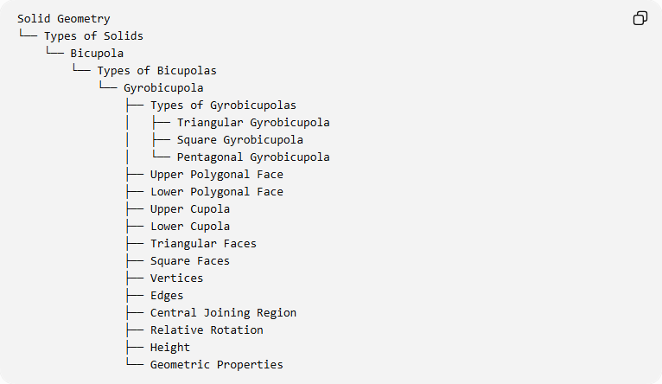
Solid Geometry
└── Types of Solids
└── Bicupola
└── Types of Bicupolas
└── Gyrobicupola
├── Types of Gyrobicupolas
│ ├── Triangular Gyrobicupola
│ ├── Square Gyrobicupola
│ └── Pentagonal Gyrobicupola
├── Upper Polygonal Face
├── Lower Polygonal Face
├── Upper Cupola
├── Lower Cupola
├── Triangular Faces
├── Square Faces
├── Vertices
├── Edges
├── Central Joining Region
├── Relative Rotation
├── Height
└── Geometric Properties

Key Points
# Source: AI Source: Provided by: [Data Path: Persons Table -> ID Column: 1, Name_En Column: Motasem Essam] -> From: [ChatGPT] on [7/25/2026]
- A gyrobicupola consists of two cupolas joined base-to-base.
- One cupola is rotated relative to the other.
- Unlike an orthobicupola, unlike lateral faces meet around the joining region.
- Its generalized face, edge, and vertex counts are $4n+2$, $8n$, and $4n$.
- The triangular, square, and pentagonal examples correspond to the Cuboctahedron, Johnson solid $J_{29}$, and Johnson solid $J_{31}$, respectively.

Conclusion
# Source: AI Source: Provided by: [Data Path: Persons Table -> ID Column: 1, Name_En Column: Motasem Essam] -> From: [ChatGPT] on [7/25/2026]
The Gyrobicupola is a bicupola formed by joining two cupolas at their larger polygonal bases with a relative rotation. Its defining characteristic is the alternating arrangement of triangular and square faces at the connection between the two cupolas.

